**5: Test by connecting to MySQL Database**

--- Reference - <https://github.com/stacksimplify/aws-eks-kubernetes-masterclass/tree/master/04-EKS-Storage-with-EBS-ElasticBlockStore/04-02-SC-PVC-ConfigMap-MySQL>

--- **note** – we are going to create all the manifests and verify them.

**Create MySQL Database with all above manifests**

**# Create MySQL Database**

--- **kubectl apply -f kube-manifests/** - whatever manifests under that it is going to create them all.

**# List Storage Classes**

--- **kubectl get sc** -

**# List PVC**

--- **kubectl get pvc** - persistent volume claim. Now you can see that it is bound. Earlier it is in pending state.



**# List PV**

--- **kubectl get pv** - persistent volume got created and it is in use.

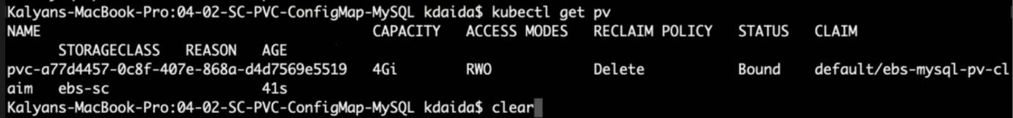

**# List pods**

--- **kubectl get pods** - our mysql pod is running.



**# List pods based on label name**

--- **kubectl get pods -l app=mysql** – this is how we can use labels.



**Connect to MySQL Database**

**# Connect to MYSQL Database**

--- **kubectl run -it --rm --image=mysql:5.6 --restart=Never mysql-client -- mysql -h mysql -pdbpassword11** -

**# Verify usermgmt schema got created which we provided in ConfigMap**

--- **mysql> show schemas;**

